This report is meant to give a concise, yet detailed description of the process of analysis of the COVID19 dataset, with respect to the capstone project of the Ustacky data science course. The aim of the project is to enable students practice the knowledge gained, including but not limited to – the basics of Python, Pandas analytics, data collection, data exploration, visualization, and the ability to make inference as well as produce suitable reports.

The datasets provided for this project include: a record of COVID19 cases in Nigeria from the website of Nigeria Center for Diseases Control (NCDC); daily record of cases across different countries from a Github repository owned by John Hopkins University CSSE; files in csv format containing information on Nigeria’s Real GDP, budgets and vulnerability index. These datasets gave access to the following information:

* Number of confirmed, recovered, and death cases across each states in Nigeria.
* Updated record of cases in the whole of Nigeria, and in 278 other countries, dated from the first day of COVID19 insurgence till the day of collection (17th May 2021).
* Budget details for each state in Nigeria.
* The real GDP for the country across all 4 quarters, over the period of 2014 to 2020.

Data from the NCDC website was collected using the BeautifulSoup module, and stored with Pandas function, ‘to_csv’. The repository-based data were obtained using the raw github link and the Pandas function, ‘read_csv’. Other datasets present on the local system were stored in a Pandas dataframe using ‘read_csv’.

The datasets were explored for missing values and incorrect data types. Then, cleaning and editing was carried out for easy analysis; such as converting string-like numbers to python recognized numeric values. Visualization was performed, to obtain the relationship between provided data, and provide useful insights. Charts used for visualization includes: line plots, bar charts, and scatter plots.

INSIGHTS DRAWN.

The top 10 states with a high number of COVID cases are Lagos, FCT, Kaduna, Plateau, Rivers, Oyo, Edo, Ogun, Kano, and Ondo. A plot of the vulnerability index with confirmed cases shows that Kaduna has felt the biggest impact of COVID 19 among these states.

There is also a record of daily increase of cases, which might be as a result of citizens’ relaxation towards the precautionary measures, like using nose masks, and maintaining certain social distancing.

The Gross Domestic Product of Nigeria also took a big hit in 2020, the year of COVID outbreak. The second quarter experienced significant reduction compared to the first, and the third barely made it above the first.

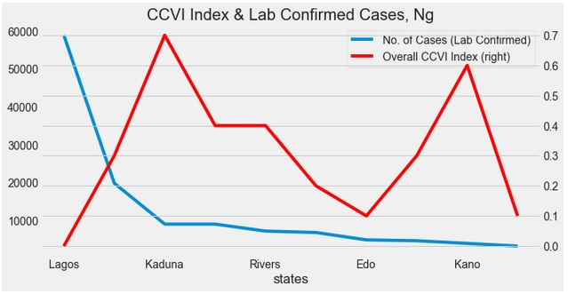

FIG 1: Relationship between the overall vulnerability index, and laboratory confirmed cases, Ng.

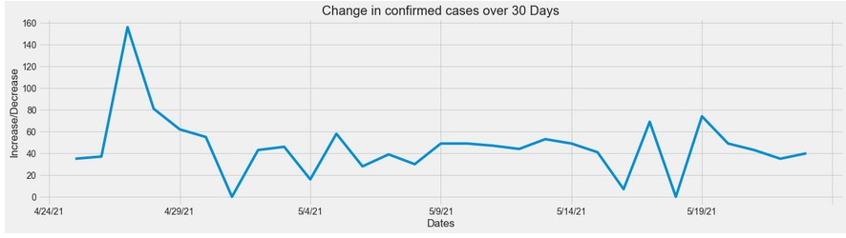

FIG 2: The rate of increase in confirmed cases, 30 days before 25th of May, 2021.

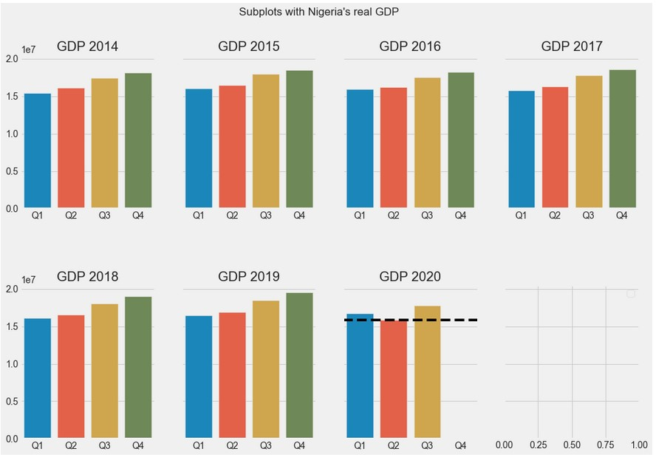

FIG 3: Trends in real GDP Nigeria, from 2014 to 2020.

CONCLUSION

Nigerian economy was greatly impacted by the outbreak of the novel coronavirus. The masses suffered health concerns as well as other survival issues such as feeding and providing for family.

To obtain a clearer impact of COVID 19, analysis can be carried out based on individual factors that influence the GDP. This will omit lesser angles, and shed more light on the less obvious but important impacts of the coronavirus. This would include private and public consumptions, investments, foreign balance of trade, etc.